Archerfalls Airfield, Queensland
26°58.453S 152°40.004E
-26.974224° 152.666730°
ELE 360 VAR 11.0°E
Procedures

RWY 18/36, 700 metre grass, Elevation 360ft AMSL

All arrivals RWY 18, All departures RWY 36
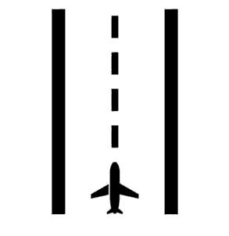
Departures commence ground roll at southern extremity RWY 36
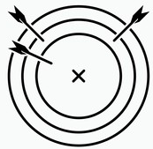
Missed approach RWY 18: make left turn immediately, climb to circuit ALT

CTN: Terrain 1660ft AMSL south 1.0NM (1300ft ABV RWY)
CTN: Terrain 1860ft AMSL south 1.8NM (1500ft ABV RWY)
CTN: Kangaroo and Bird hazard
CTN: Powerlines short final RWY 18
CTN: Model aircraft OPS

Avoid flying directly over houses to North, East, West

CTAF 126.7, FIA BRISBANE CENTRE 129.0
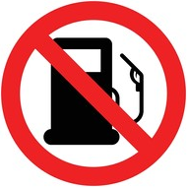

Fuel NOT AVBL, YCAB or YWSG

CTC: Ron Field 0408195497, 1253 Neurum Rd, Mt Archer Q 4514
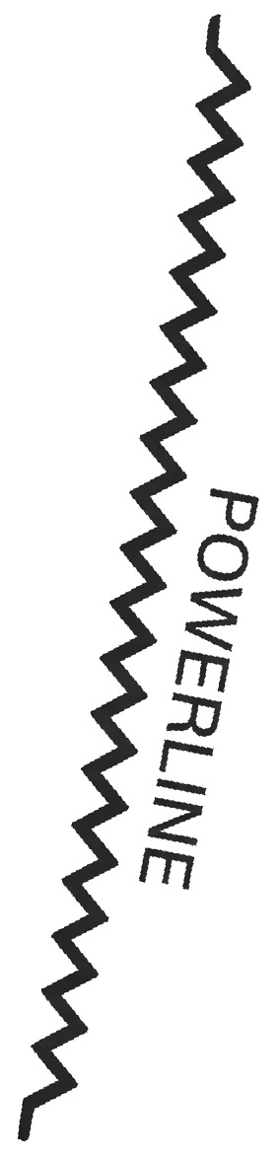
700m
18
36
YBAF
153°M
40NM
YAMB
177°M
40NM
YRED
123°M
26NM
KLCY
290°M
6NM
Mt Archer
180°M
2NM
ELE 1860ft
YTWB
230°M
53NM
YCAB
110°M
18NM
YKCY
272°M
5NM
YWSG
237°M
13NM
YCDR
066°M
26NM
House
YBSU
046°M
32NM

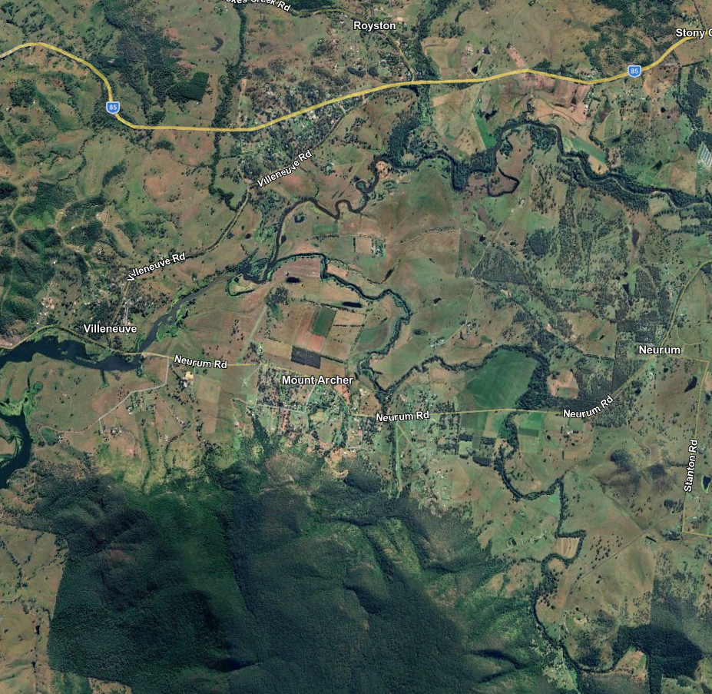

700m
1860ft
AMSL
360ft
AMSL

