Stover, Queensland
27°30.020S 152°31.194E
-27.500330° 152.519894°
VAR 10.9°E
Procedures
RWY 10/28
960 metre clay dirt and grass
Elevation 226ft AMSL
CTAF 126.7
FIA BRISBANE CENTRE 121.2
CTN Powerlines cross runway at 90°, 25ft AGL, 775m FM RWY10 THR, 185m FM RWY28 THR
CTN Powerlines short final RWY10, 60ft AGL

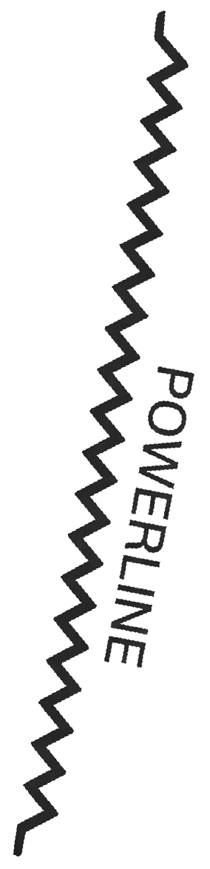

960m
10
28
YBAF
089°M
26NM
YAMB
120°M
13NM
YGAS
237°M
15NM
YWSG
341°M
24NM
YBOA
154°M
32NM
YTWB
254°M
33NM
YBCM
322°M
7NM
YKCY
353°M
32NM
YKRY
315°M
66NM
Brightview
242°M
1.8NM
25ft AGL
60ft AGL
House

Stover, Queensland
27°30.020S 152°31.194E
-27.500330° 152.519894°
VAR 10.9°E

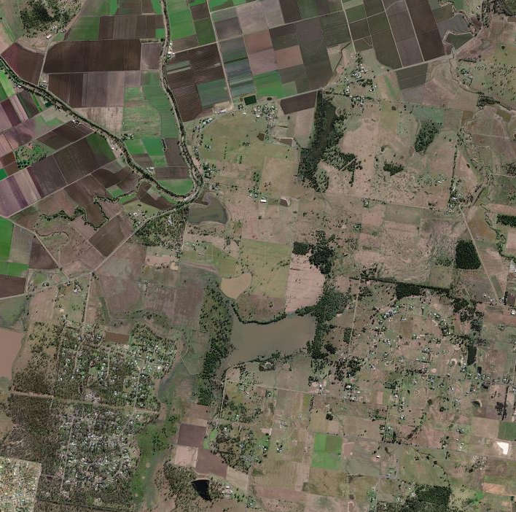
960m
10
28
Brightview

